Kennesaw State University
Department of Computer Science
College of Science and Mathematics

CS 4720 Section 01 Introduction to Computational Science - Fall 2014

Assignment No. 7
-------------------------------------------------
"Vector and Matrix Operation"

Richard Godbee
rgodbee1@students.kennesaw.edu

October 3, 2014

Initial Problem Statement:

Develop a C program that computes the values in a vector V that are the sines of the elements of vector T. The program must assign to T a vector with 75 elements running from 0 to 2π. Plot the elements of V as a function of the elements of T; use GSL vectors and GnuPlot.

A computational model has a mathematical representation as a set of three linear equations. Find the solution to the following set of linear equations using LU elimination, and implement with C and the GSL.

Summary and Purpose of the Assignment Activity:

Temperature Values over a 12-hour Period
The main problem for assignment 7 is to determine the values of a sin function from 0 to 2π . The problem utilized the gnu scientific library for the function gsl_vector_set() and the sin() function for the math.h library. The basic_lib library was used in these computations to fill the input data arrays. The compile code for the first problem is as follows:
gcc -Wall -o vector_sin vector_sin.c -lm -lgsl -lgslcblas basic_lib.o

The second problem uses matrix operations to solve a set of linear equations. The solution to the following set of linear equations using LU elimination used gsl_linalg_LU_decomp and gsl_linalg_LU_solve to find the solution to the matrix. The compile code for the second problem is as follows:
gcc -Wall -o matrix matrix_solution.c -lgsl -lgslcblas

Data Table:
Problem 1:
Input Data :
linspace (T, 0, (2*M_PI), N);
Input 75 values from 0 to 2π

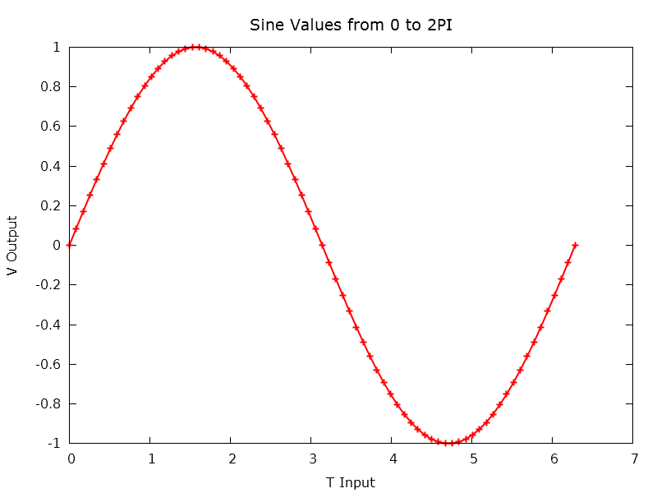
Problem 2:
Input Data points:
matrixA[3][3]= {{3.0, 5.0, 2.0},
{2.0, 3.0, -1.0},
{1.0, -2.0, -3.0}};
vectorB[3]= {8.0,1.0,-1.0};

Solution
{3, -1, 2}
B = 3x-1y+2z
Source Code:

Problem 1:
Program: vector_sin.c
#include <stdio.h>
#include <gsl/gsl_vector.h>
#include <math.h>
#include "basic_lib.h"
#define M_PI 3.14159265358979323846
int main (void) {
const int N = 75;
// double data[N];
int i;
// gsl_vector * T = gsl_vector_alloc (N);
// gsl_vector * V = gsl_vector_alloc (N);
double T[N];
double V[N];
// gsl_vector_set_all(T, 0.0);
// gsl_vector_set_all(V, 0.0);
// creat input data
// linspace (data, 0, 2*M_PI, N);
linspace (T, 0, (2*M_PI), N);
//store input data into the matrix
// for(i = 0; i < N; i++)
// gsl_vector_set(T, i, data[i]);
// compute the sin value
for (i = 0; i < N; ++i)
// gsl_vector_set(V, i ,sin(data[i]));
V[i] = sin(T[i]);
// print the input vector and output vector
printf("Line\tInput T\tOutput V\n");
for (i = 0; i < N; i++)
printf ("%d\t%g\t%g\n", i, T[i], V[i]);
// gsl_vector_free (T); // release allocated memory
// gsl_vector_free (V); // release allocated memory
// free(T);
// free(V);
return 0;
}

Problem 2:
Program: matrix_solution.c
#include <stdio.h>
#include <gsl/gsl_linalg.h>
int main (void) {
int row = 3; // number of rows in A
int column = 3; // number of columns in A
double matrixA[3][3]= { {3.0, 5.0, 2.0},
{2.0, 3.0, -1.0},
{1.0, -2.0, -3.0} };
double vectorB[3]= {8.0,1.0,-1.0};
int i; int j; int s;
gsl_matrix * mmat = gsl_matrix_alloc (row, column);
gsl_vector * b = gsl_vector_alloc(column);
gsl_vector *x = gsl_vector_alloc (column);
// input values into matrixA
for (i = 0; i < row; i++)
{
for (j = 0; j < column; j++)
{
gsl_matrix_set (mmat, i, j, matrixA[i][j]);
}
}
// Input values into vectorB
for (i = 0; i < column; i++)
{
gsl_vector_set(b, i, vectorB[i]);
}
gsl_permutation * p = gsl_permutation_alloc (column);
gsl_linalg_LU_decomp (mmat, p, &s);
gsl_linalg_LU_solve (mmat, p, b, x);
printf ("Solution Vector: \n");
gsl_vector_fprintf (stdout, x, "%g");
gsl_matrix_free (mmat);
gsl_permutation_free (p);
gsl_vector_free (x);
return 0;
}

Comments and Conclusion:
Working on these different problems showed that vector manipulation and linear solutions can be found using the gsl library functions.

Assignment Questions:
1) Develop a C program that computes the values in a vector V that are the sines of the elements of vector T. The program must assign to T a vector with 75 elements running from 0 to 2π. Plot the elements of V as a function of the elements of T; use GSL vectors and GnuPlot.
The implementation of the C code is shown above. The values used in the calculations are shown on page 4. The program is used to evaluate the sin values at several points to aid in graphing.

2) A computational model has a mathematical representation as a set of three linear equations. Find the solution to the following set of linear equations using LU elimination, and implement with C and the GSL.

The implementation of the C code is shown above. The values used in the calculations are on page 4. The program uses linked lists. The program is used to evaluate the set of linear equations.

References:

Garrido, J. M., 2014, Introduction to Computational Modeling using C and Open-source Tools, CRC Press/Taylor & Francis Group, Boca Raton, FL.

